Build and deploy web application – Azure Cloud

* Kaviya Sri A N

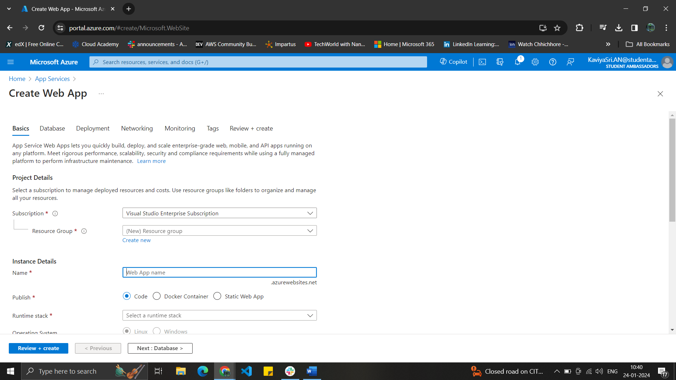

Creating the web app by creating the resource group and the instance details with Name ,Runtime stack and OS.

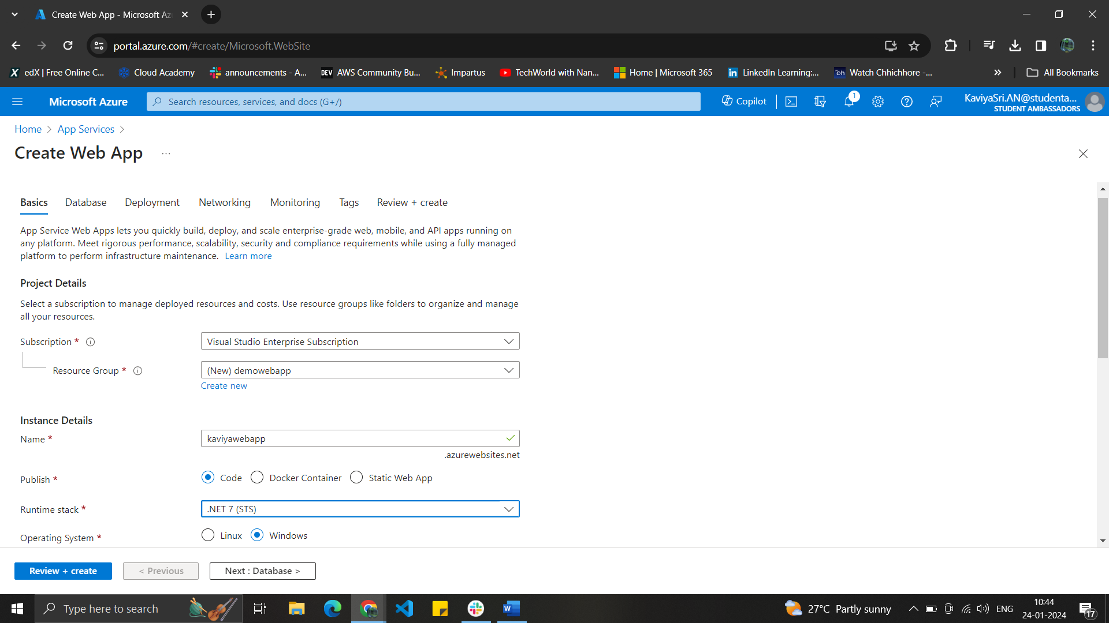

The region is set up along with pricing plans.

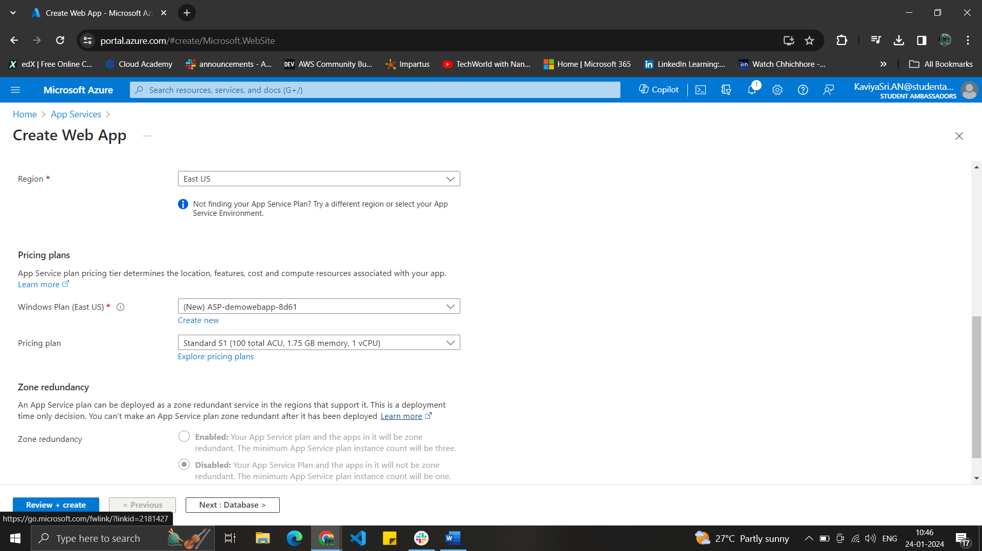

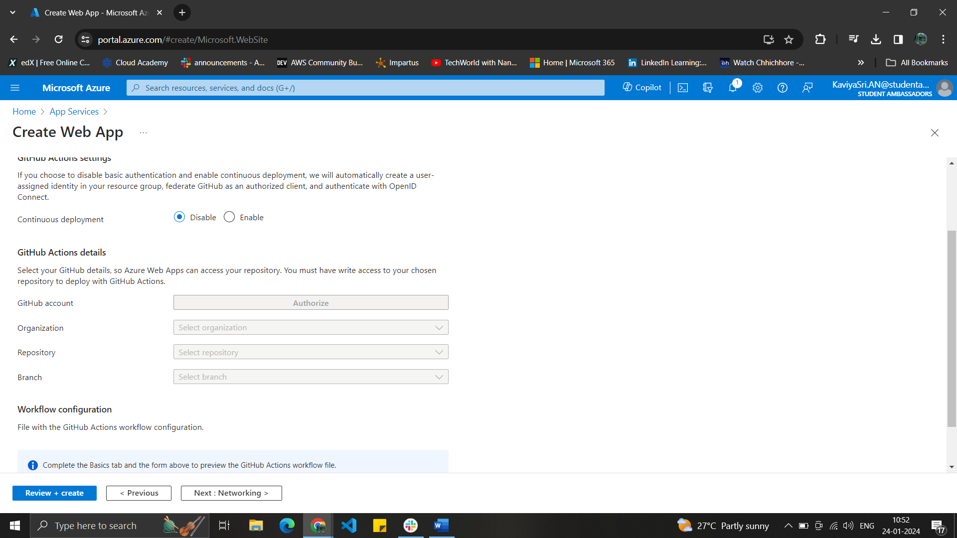

Enabled the public access.

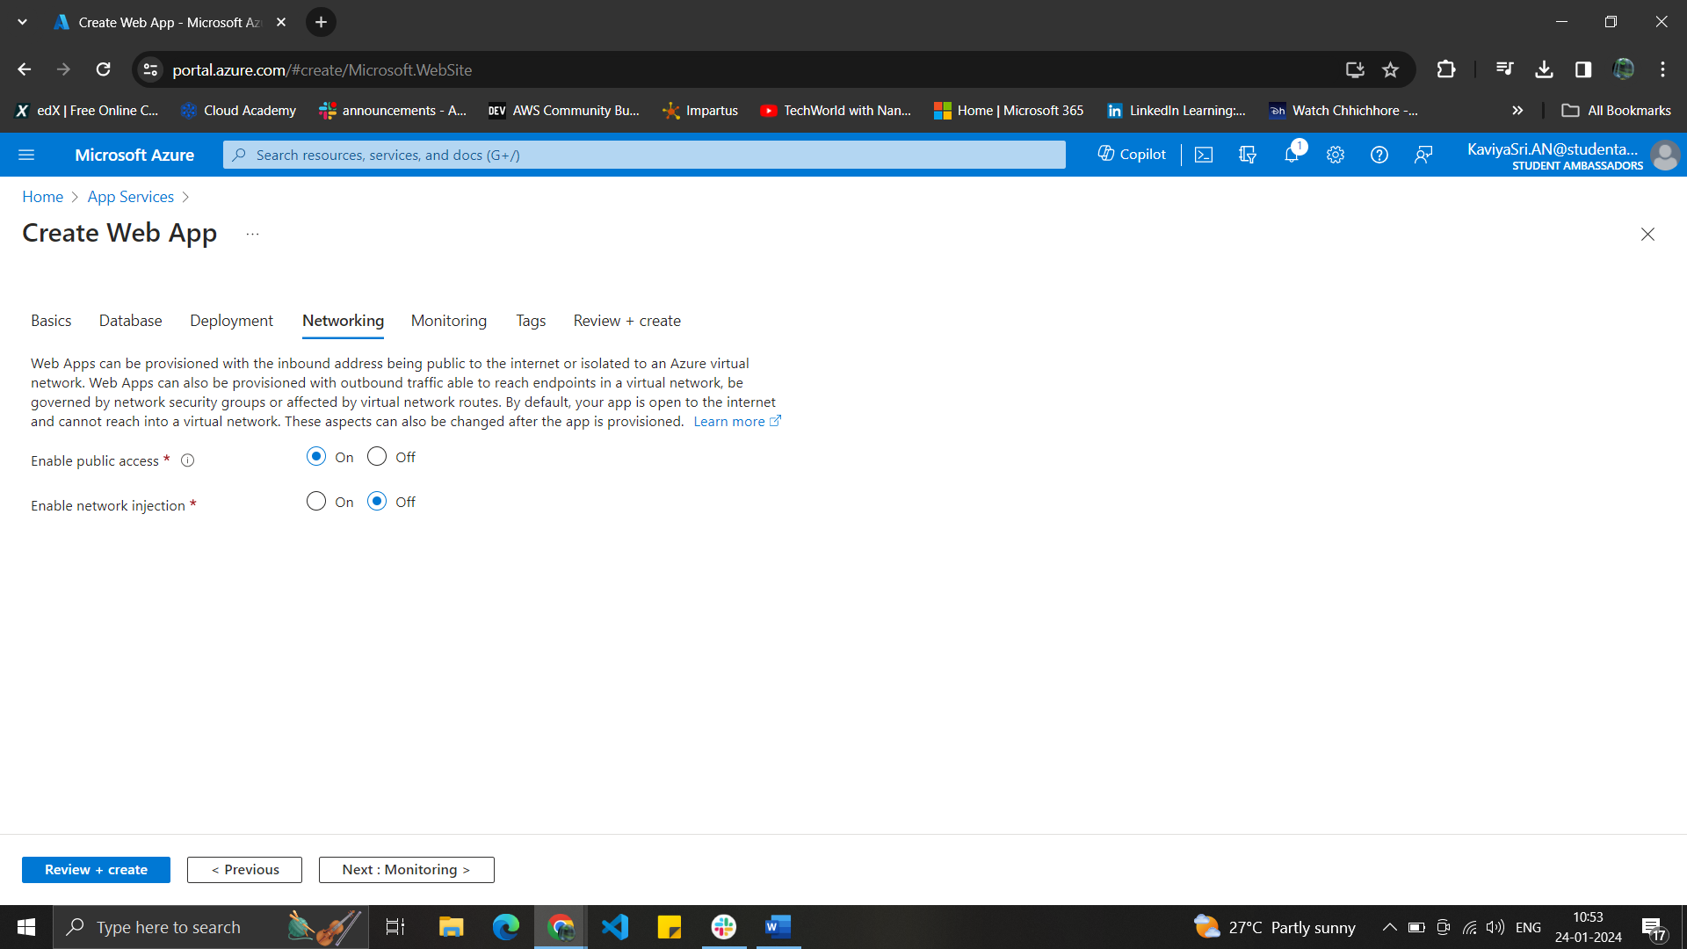

Monitoring is configured.

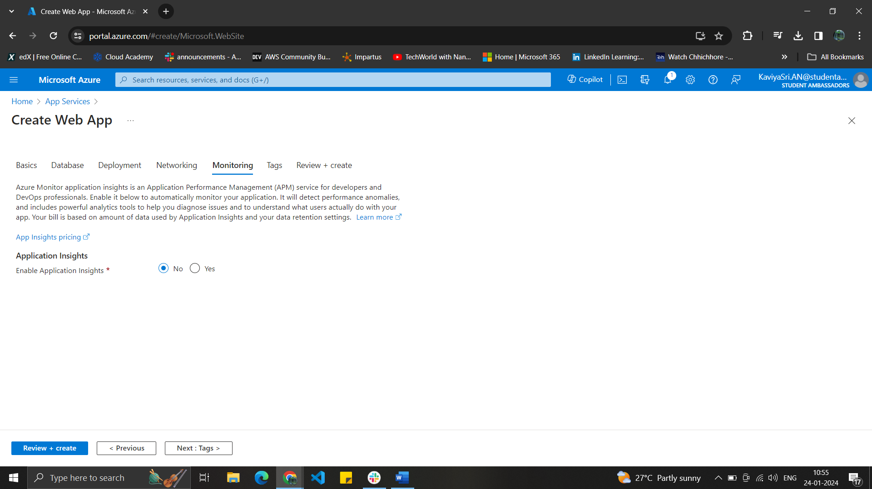

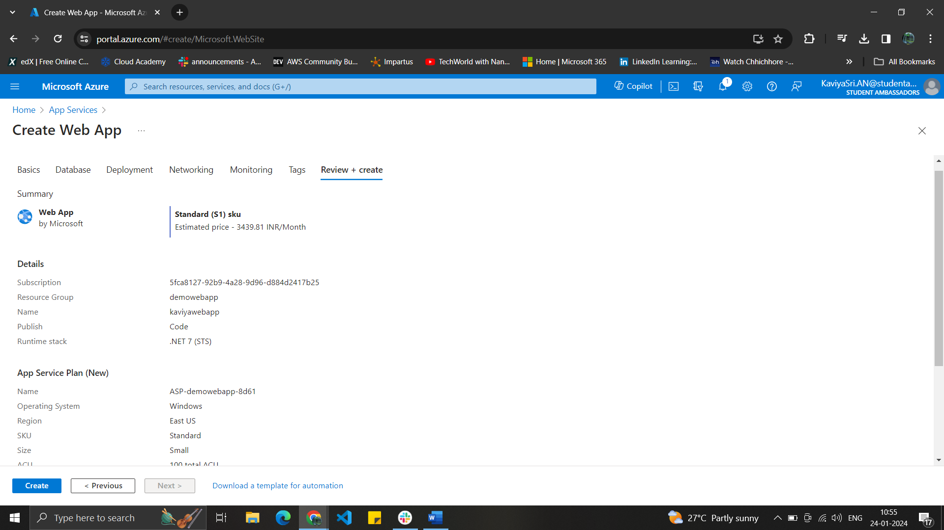

Web App is created and deployed

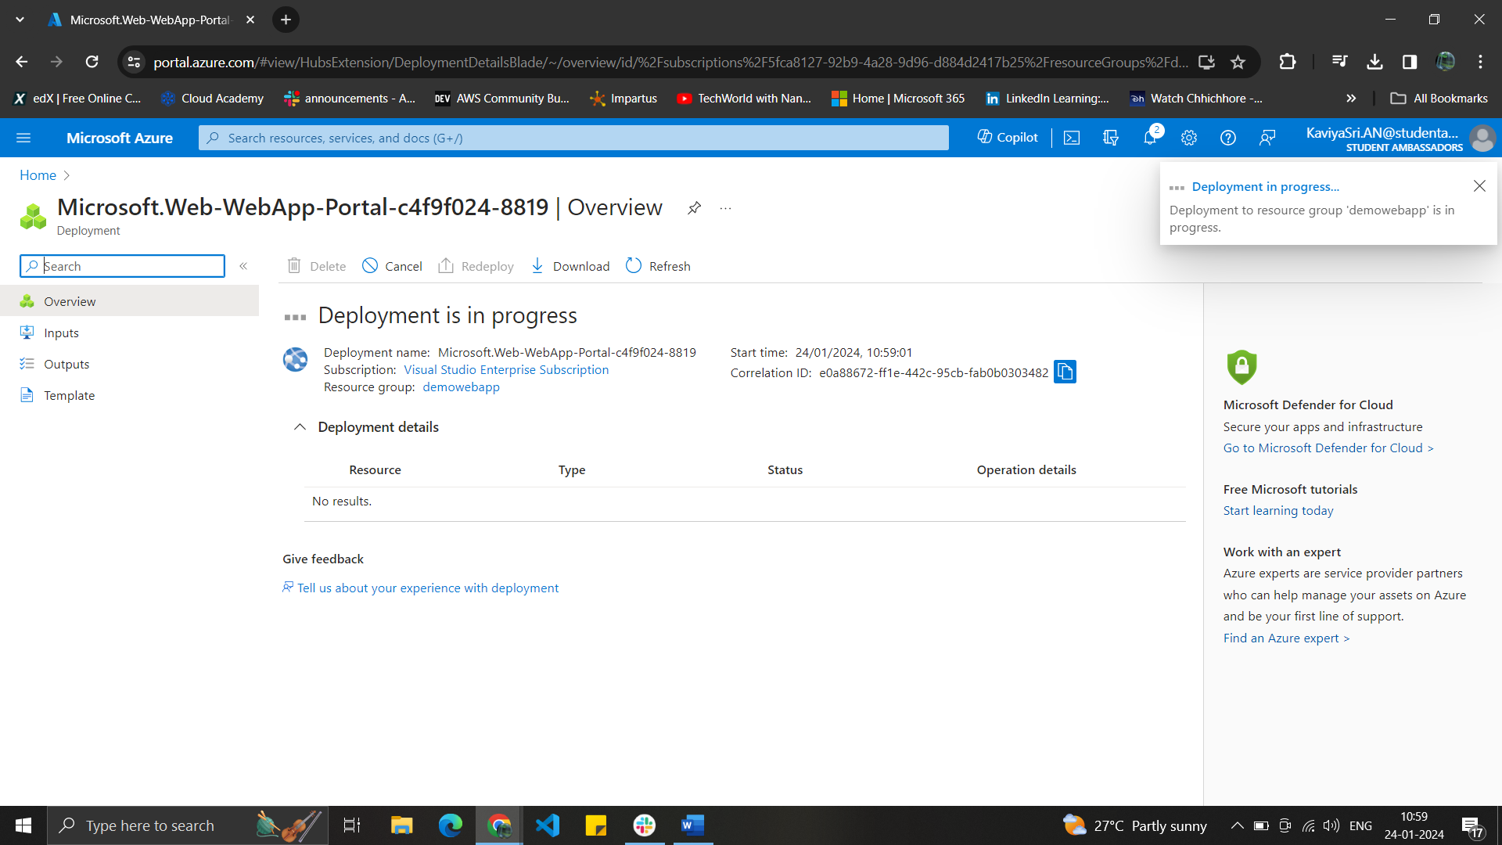

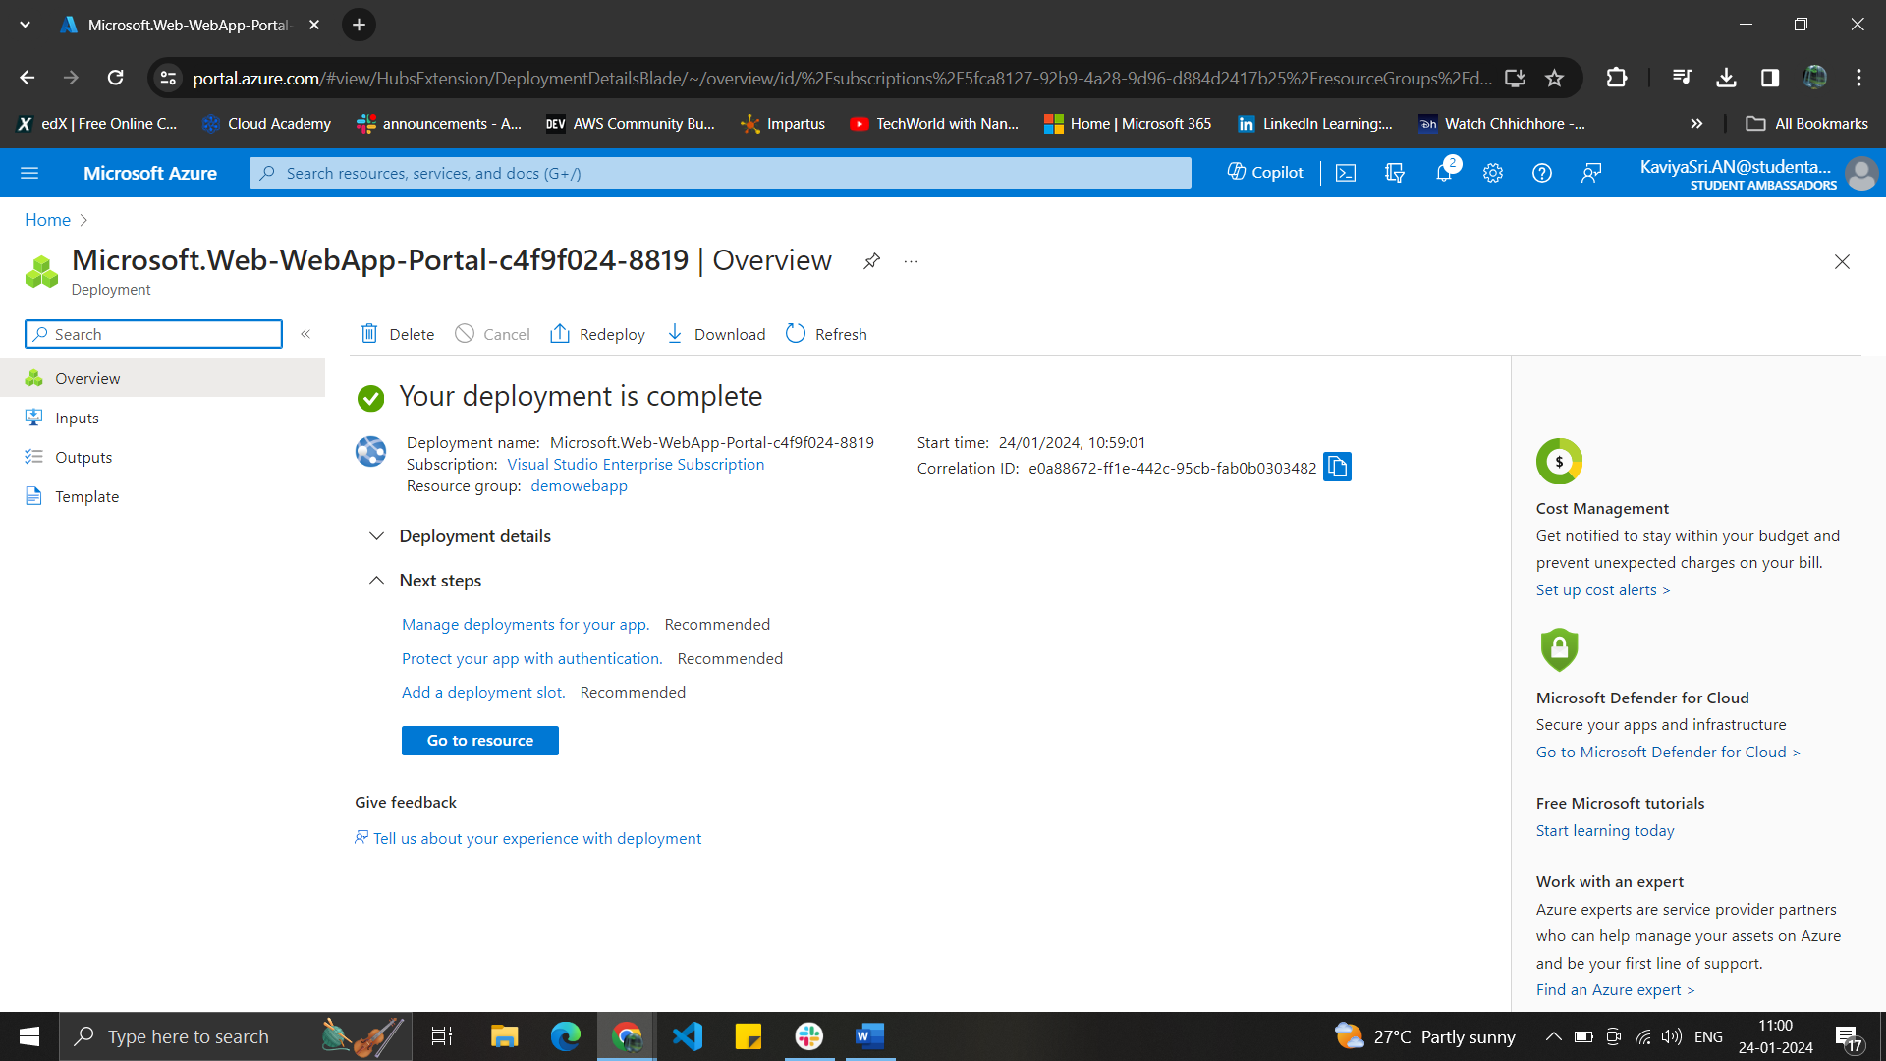

Web App is successfully deployed and the site can be accessed with the default domain.

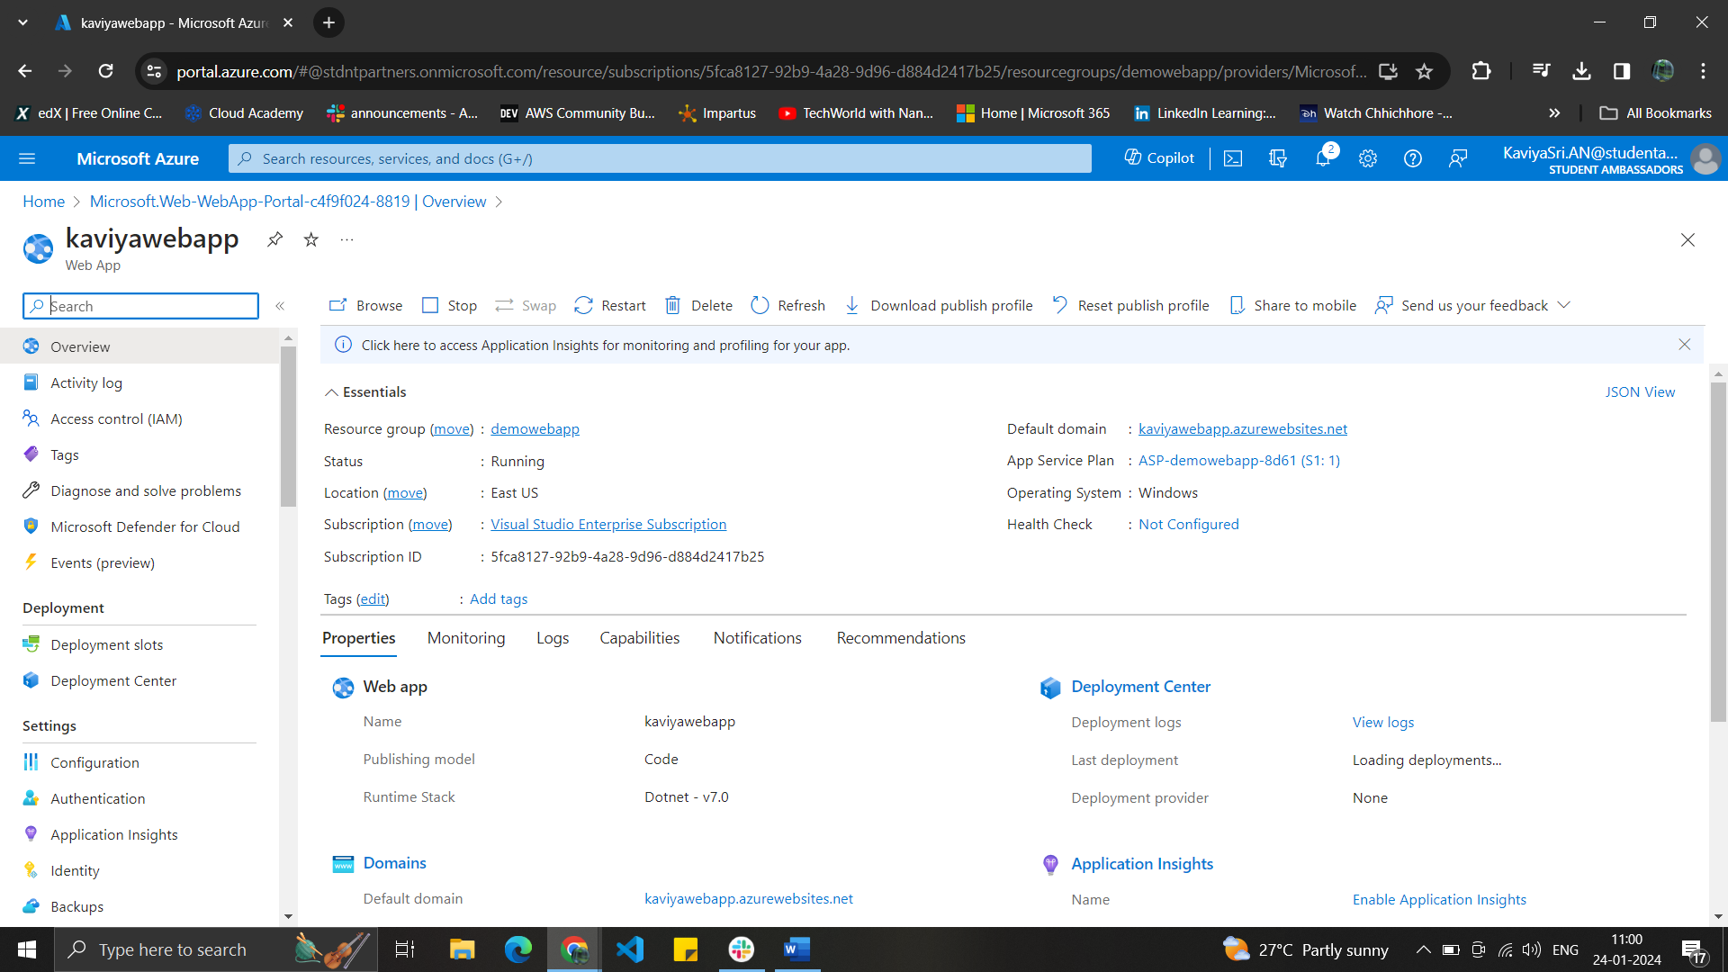

Web App is in running state and it is accessed through the default domain.

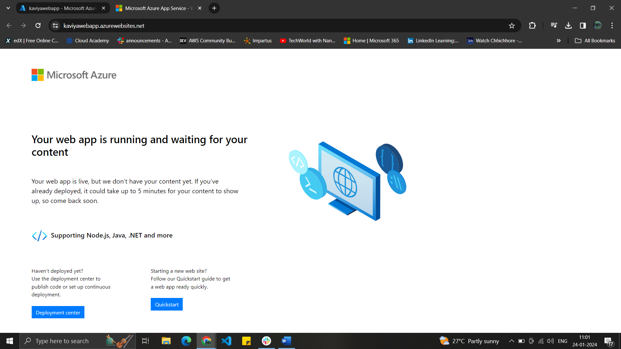

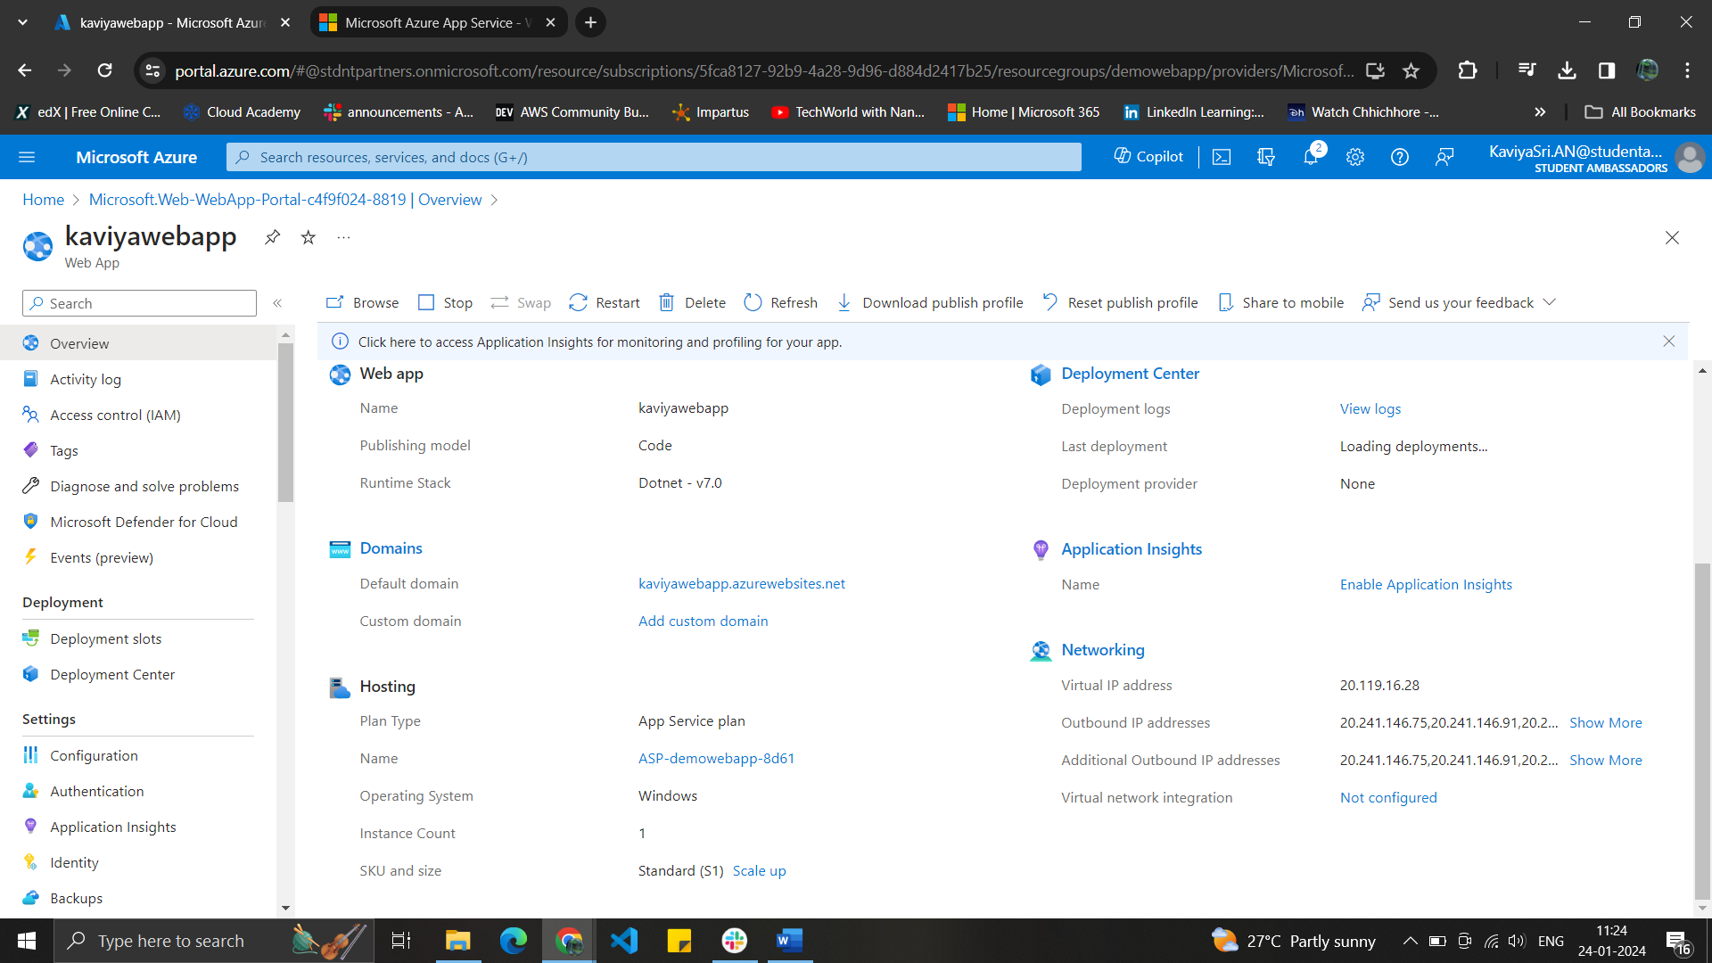

Deployed Web Url - https://kaviyawebapp.azurewebsites.net/